At TVJC 27/05/16

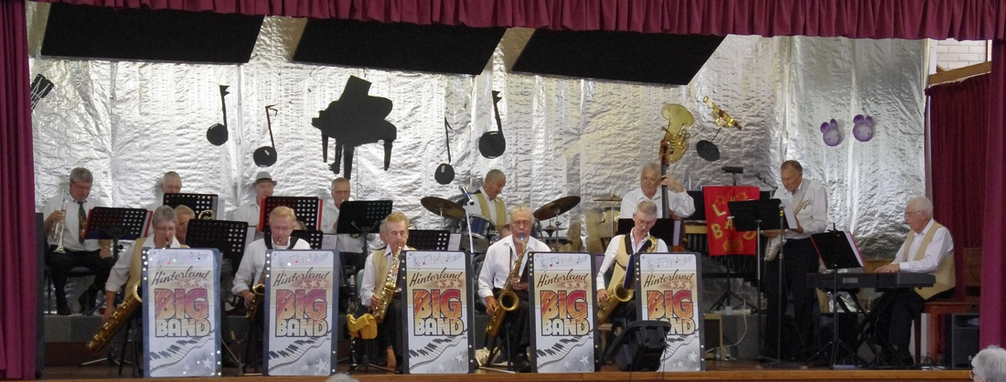
The TVJC is very excited to have this band for the second time and is part of our program to keep big bands alive! The last time this band played was January 2015 to an enthralled audience.
Band leader Roger Munsie engaged the crowd with an almost endless set of history or interesting anecdotes about the songs they were performing, some going back to the 1920’s.
The repertoire consists mainly of well-trodden big band material of the 30’s and 40’s such as Benny Goodman, Artie Shaw, Glenn Miller and Duke Ellington. The swing dancers seemed to never be off their feet!
This band consists of 15-16 dedicated players who are keeping alive the wonderful music of the big band era, with some other interesting modern pieces added to the repertoire.
Band line-up is led by the very talented Roger Munsie on alto sax and clarinet. Other prominent musicians in the group include Tab Paenga on Tenor sax, John Edwards on bass, Gary Matthews on piano, Martin Wyatt on guitar, Barry McKenna on alto sax and Reg Payne on baritone sax. They play dances at the last remaining ball rooms on the Gold Coast and are looking forward to playing for us.
(Attendance 71 Patrons)

